1. Quad  
   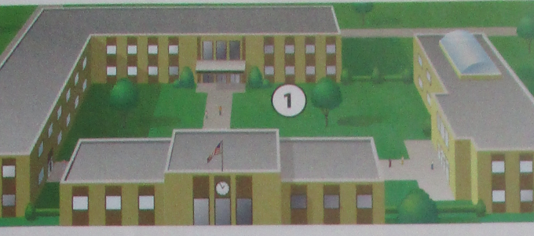  
   Lakou
2. Field  
   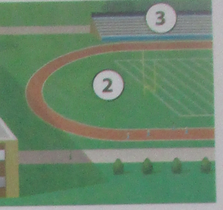  
   Teren
3. Bleachers  
     
   Tribin
4. Principal  
   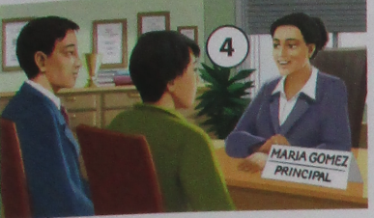  
   Direktè
5. Assistant Principal  
   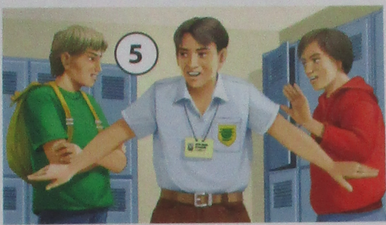  
   Asistan Direktè
6. Counselor  
   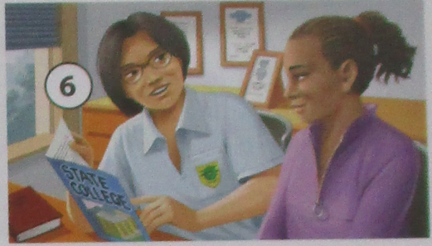  
   Konseye
7. Classroom  
   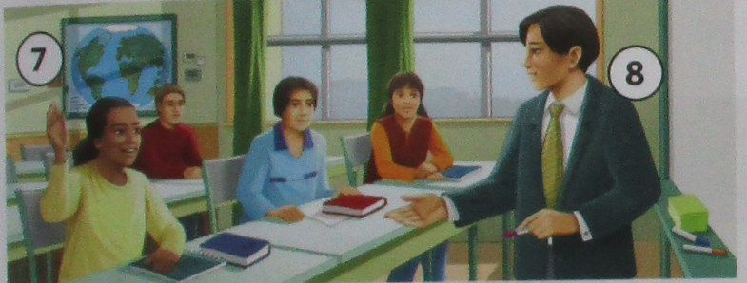  
   Sal de klas
8. Teacher  
     
   Pwofesè
9. Restrooms  
   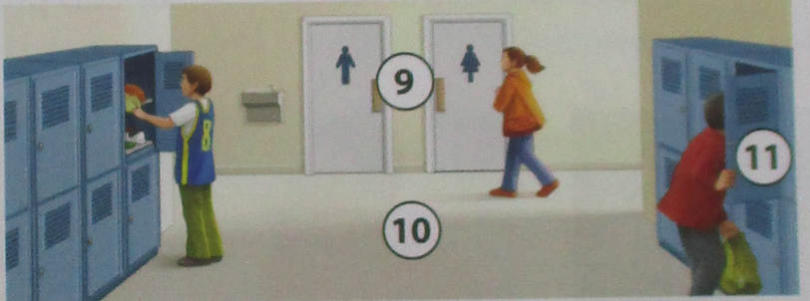  
   Twalèt
10. Hallway  
      
    Koulwa
11. Locker  
      
    Lamwa
12. Main office  
    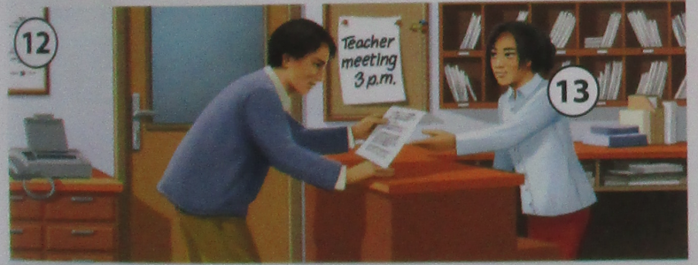  
    Biwo prensipal
13. Clerk  
      
    Anplwaye biwo
14. Cafeteria  
    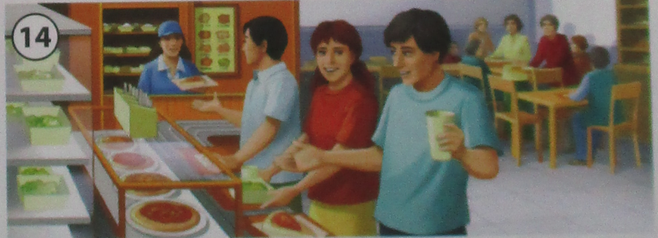  
    Kafeterya
15. Computer lab  
      
    Laboratwa enfòmatik
16. Teacher’s aide  
      
    Asistan pwofesè
17. Library  
      
    Bibliyotèk
18. Auditorium  
    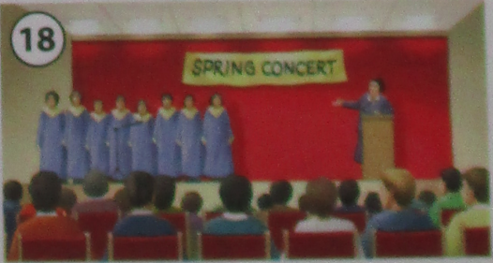  
    Oditoryòm
19. Gym  
    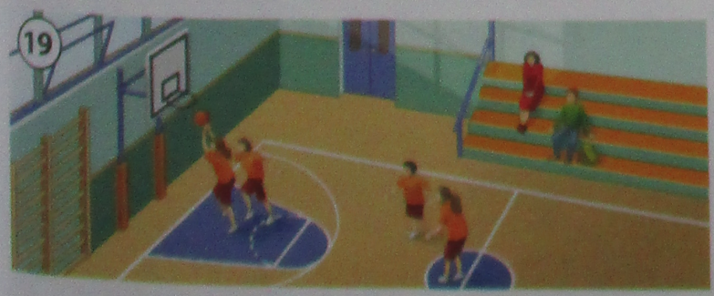  
    Sal egzèsis
20. Coach  
    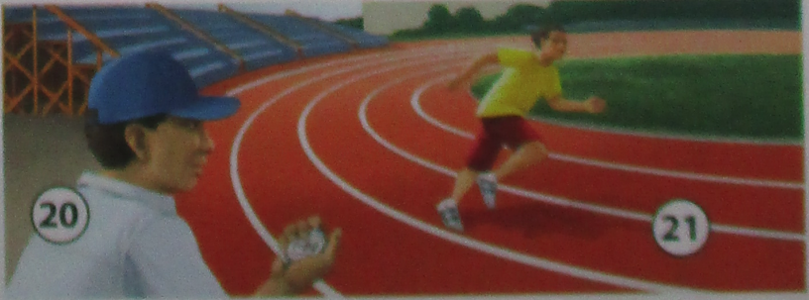  
    Antrenè
21. Track  
      
    Pis